LIBRARY MANAGEMENT SYSTEM(LMS)

**Aim:** Library management system aims in developing a computerized system to maintain all the daily work of library. It is a term for computer-based system that manage the catalogue of a library. The main purpose of this system is to manage library daily operation efficiently. The application is designed for the use of librarians and library users.

Objectives of Library Management System (LMS)

* It has a facility of admin login through which the admin can monitor the whole system. It has a facility where member after logging in their accounts can see list of books issued and its issue date and return date.
* It will store all the books and members information that consist of book numbers, book titles, author names and racks to the system database.
* It also provides search function to help find the book by number of book.
* Search function will search through the books database to look for the book and view where the book is situated.
* Administrator can handle administrative functions such as create new LMS user account and decide the number of days allowed for the borrowed books.
* Users can visit the site of the library and can decide to register as a student, teacher or a regular member and will have a subscription plan accordingly, once the user has become a member the user can login to view the availability of the books they want to borrow in the library.

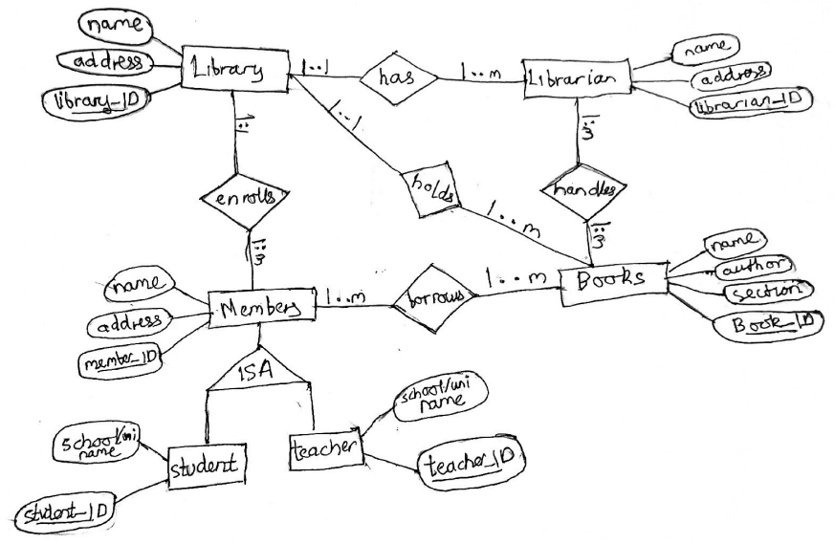**ER Diagram for the Library Management System**